**CL-IX (Distributed Computing Systems Lab)**

Assignment 4

# Roll No : 43159

**Name :** Sakshi Tantak

# Batch : P-11

# Problem Statement :

To develop any distributed algorithm for leader election.

# Objectives:

By the end of this assignment, the student will be able to explain the concept of Leader Election Algorithms.

# Tools: Eclipse,Java8 Theory:

# Distributed Algorithm

* Distributed Algorithm is a algorithm that runs on a distributed system. Each processor has its own memory and they communicate via communication networks.
* Many algorithms used in distributed system require a coordinator that performs functions needed by other processes in the system. ● Election algorithms are designed to choose a coordinator. ● Why Election Algorithm?

○ Many distributed algorithms require a process to act as a coordinator.

○ The coordinator can be any process that organizes actions of other processes.

○ A coordinator mayfail.

○ How is a new coordinator chosen or elected?

# Election Algorithm

● Assumptions:–

Each process has a unique number to distinguish them. Processes know each other's process number.

There are two types of ElectionAlgorithms:

1. BullyAlgorithm
2. RingAlgorithm

# Bully Algorithm

* BullyAlgorithm : This algorithm applies to system where every process can send a message to every other process in the system.
* Algorithm – Suppose process P sends a message to the coordinator. 1. If coordinator does not respond to it within a time interval T, then it is assumed that coordinator has failed.
  1. Now process P sends election message to every process with high priority number.
  2. It waits for responses, if no one responds for time interval T then process P elects itself as a coordinator.
  3. Then it sends a message to all lower priority number processes that it is elected as their new coordinator.
  4. However, if an answer is received within time T from any other process Q,
     1. Process P again waits for time interval T’ to receive another message from Q that it has been elected as coordinator.
     2. If Q doesn’t responds within time interval T’ then it is

assumed to have failed and algorithm is restarted.

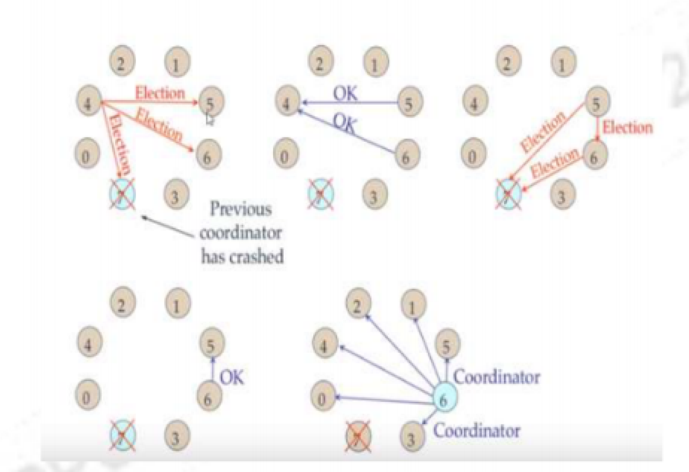

# Ring Algorithm

* RingAlgorithm:

This algorithm applies to systems organized as a ring (logically or physically). In this algorithm we assume that the link between the process are unidirectional and every process can message to the process on its right only. Data structure that this algorithm uses is active list,a list that has priority number of all active processes in the system.

* Algorithm–

○ If process P1 detects a coordinator failure, it creates new active list which is empty initially. It sends election message to its neighbour on right and adds number 1 to its active list.

○ If process P2 receives message elect from processes on left, it responds in 3 ways:

■ If message received does not contain 1 in active list then P1 adds 2 to its active list and forwards the message.

■ If this is the first election message it has received or sent, P1 creates new active list with numbers 1 and 2. It then sends election message 1 followed by 2

■ If Process P1 receives its own election message 1 then active list for P1 now contains numbers of all the active processes in the system.Now Process P1 detects highest priority

number from list and elects it as the new coordinator

.

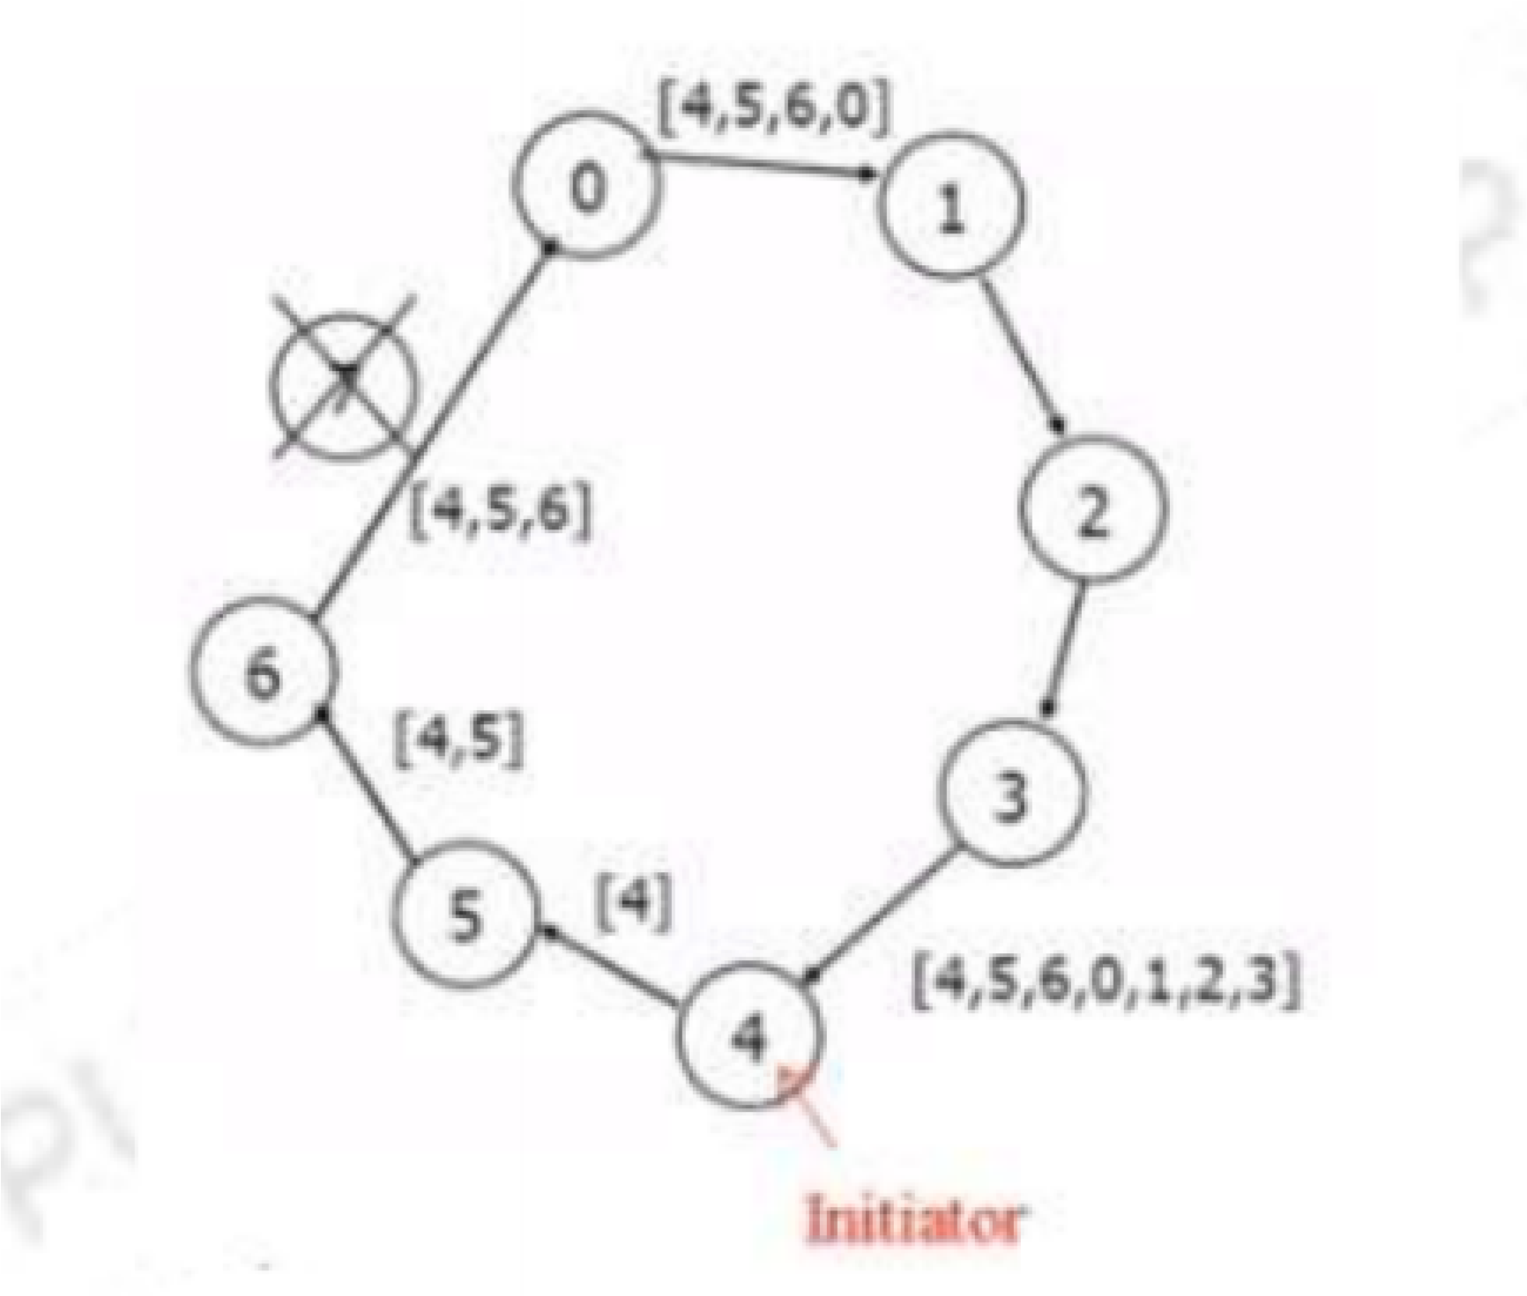

# Conclusion:

Thus, in this assignment I learnt about election algorithms in distributed systems and I implemented Bully and Ring election algorithms